Bìa

* Thành viên nhóm
* Tên trường, tên project, tên lớp

Giới thiệu

Lời cảm ơn

Table of Contents

**1.** **Introduction to Game RushRelic (mordern remake of RushHour)** 5

**a.** **Installation** 5

**i.** **Github** 5

**ii.** **Zipped file** 5

**iii.** **Video Youtube** 6

**b.** **Interface** 6

**i.** **Screens layout and flow** 6

**ii.** **Gameplays** 9

**c.** **Design system and Design pattern** 15

**i.** **System Class** 15

**ii.** **Core Game Classes: Map and Vehicle** 16

**2.** **Description of the Maps** 17

**a.** **Foudational Elements in a Map** 18

**b.** **Map Details** 18

**i.** **Map 1** 18

**ii.** **Map 2** 18

**iii.** **Map 3** 18

**iv.** **Map 4** 18

**v.** **Map 5** 18

**vi.** **Map 6** 18

**vii.** **Map 7** 18

**viii.** **Map 8** 18

**ix.** **Map 9** 18

**x.** **Map 10** 18

**3.** **Search Algorithm Description** 18

**a.** **Input and Output Specification** 18

**b.** **State Representation and Visited Table** 18

**c.** **Solvers explaination** 18

**i.** **BFS Solver** 18

**ii.** **DFS Solver** 18

**iii.** **UCS Solver** 18

**iv.** **A* Solver** 18

**4.** **Experiments** 18

**a.** **Search Time** 18

**i.** **Measurements** 18

**ii.** **Visualizations** 18

**iii.** **Insight** 18

**b.** **Memory Usage** 18

**i.** **Measurements** 18

**ii.** **Visualizations** 18

**iii.** **Insight** 18

**c.** **Expanoded** 18

**i.** **Measurements** 18

**ii.** **Visualizations** 18

**iii.** **Insight** 19

**5.** **Project Plan and Task Distribution** 19

**a.** **Project Plan** 19

**b.** **Task Distribution** 19

**6.** **References** 19

**7.** **Apendix** 19

**8.** **Knowledgement** 19

1. **Introduction to Game RushRelic (mordern remake of RushHour)** 
   1. **Installation**

Naturally, downloading the game is the first step, as only by experiencing it visually can you form an accurate evaluation. In this section, I will guide you through **two ways** to download the RushRelic game: **Github** and **Zipped file.**

* + 1. **Github**

This is our github link: [github](https://github.com/HappyDuckCoder/AIRushHour)

Then you follow these steps to download the games, I will assumed that you have already installed **git** and **python**.

* **Step 1:** Open your folder want to store the game
* **Step 2:** Open terminal and use this command:

git clone <https://github.com/HappyDuckCoder/AIRushHour> .

* **Step 3:** Then you fild the folder code (this folder also the folder contains entires our source code, include main.py)

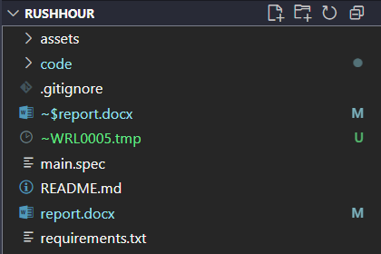

*Image 1.a.i.1: Find the folder code*

* **Step 4:** Run the **main.py** file. Of course, the game may not run immediately due to missing libraries. To resolve this, I have prepared a **requirements.txt** file that includes all the necessary packages. You can review and install them easily.
  + 1. **Zipped file**

This method is nearly identical to Method 1. However, this time you will receive a zipped folder. Simply extract the zip file and follow the same four steps mentioned above.

* + 1. **Video Youtube**

This is our YouTube introduction video for the game. We hope you can take a moment to check it out.

Video youtube link: [youtube.](https://www.youtube.com/watch?v=wd5yt_t9hGA)

* 1. **Interface**
     1. **Screens layout and flow**

This part will introduce you the interface of the game.

* + - 1. **Introduction screen:** Initiate screen introduce you to the game, only contain the title “RushRelic”.
      2. **Menu screen:** There are 5 other screens for you to choose.

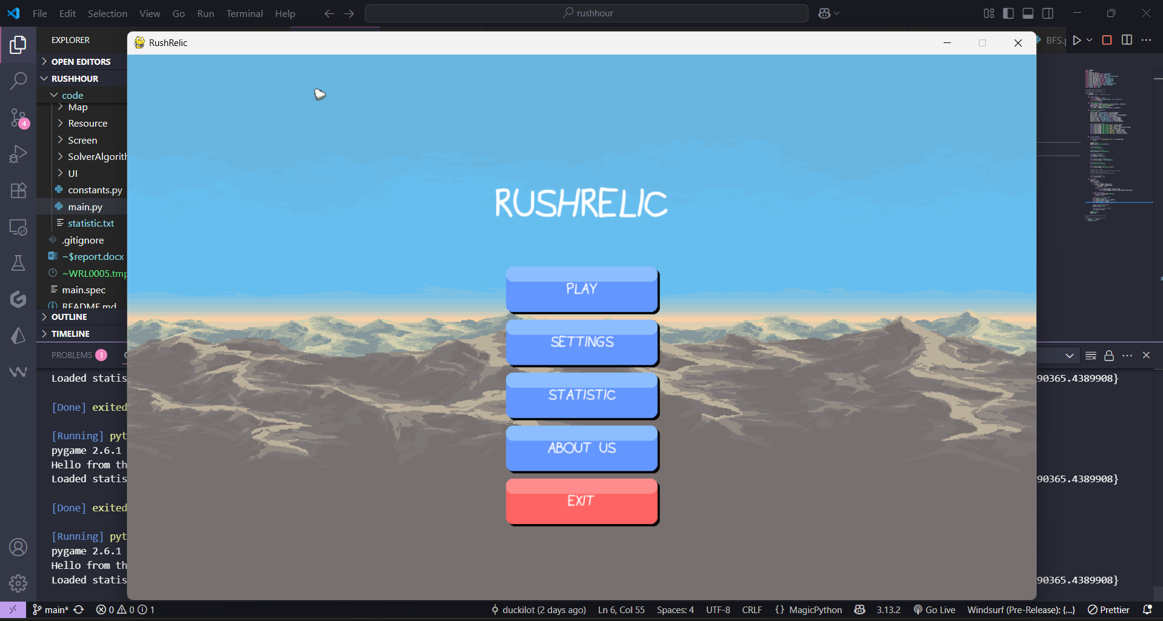

***Image 1.b.i.1****: Menu screen*

* + - 1. **Setting screen:** You can mute the sound or adjust the music volume based on your preference. You can see this screen when you choose “**SETTING**” in menu screen.

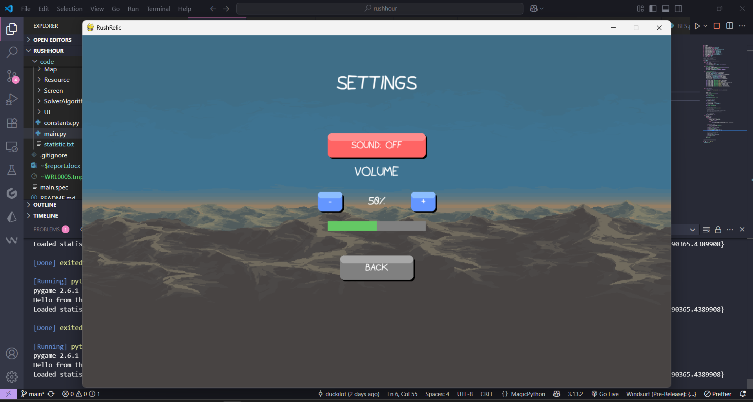

***Image 1.b.i.2****: Setting screen*

* + - 1. **Statistic screen:** Display the chart of comparing algorithms. You can see this screen when you choose “**STATISTIC**” in menu screen.

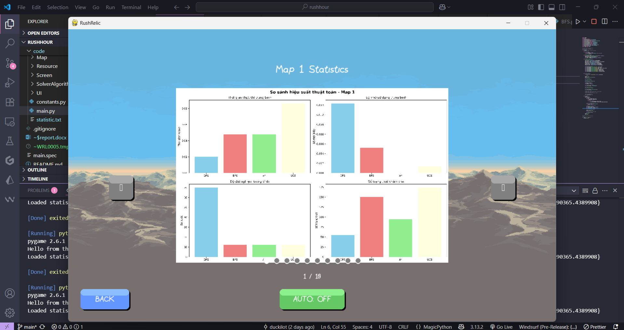

***Image 1.b.i.3****: Statistic screen*

* + - 1. **About us screen:** This screen displays our team members and their respective roles. You can see this screen when you choose “**ABOUT US**” in menu screen.
      2. **Lever select screen:** This screen display 10 levels of the game, you can see this screen when you choose “**PLAY**” in menu screen.

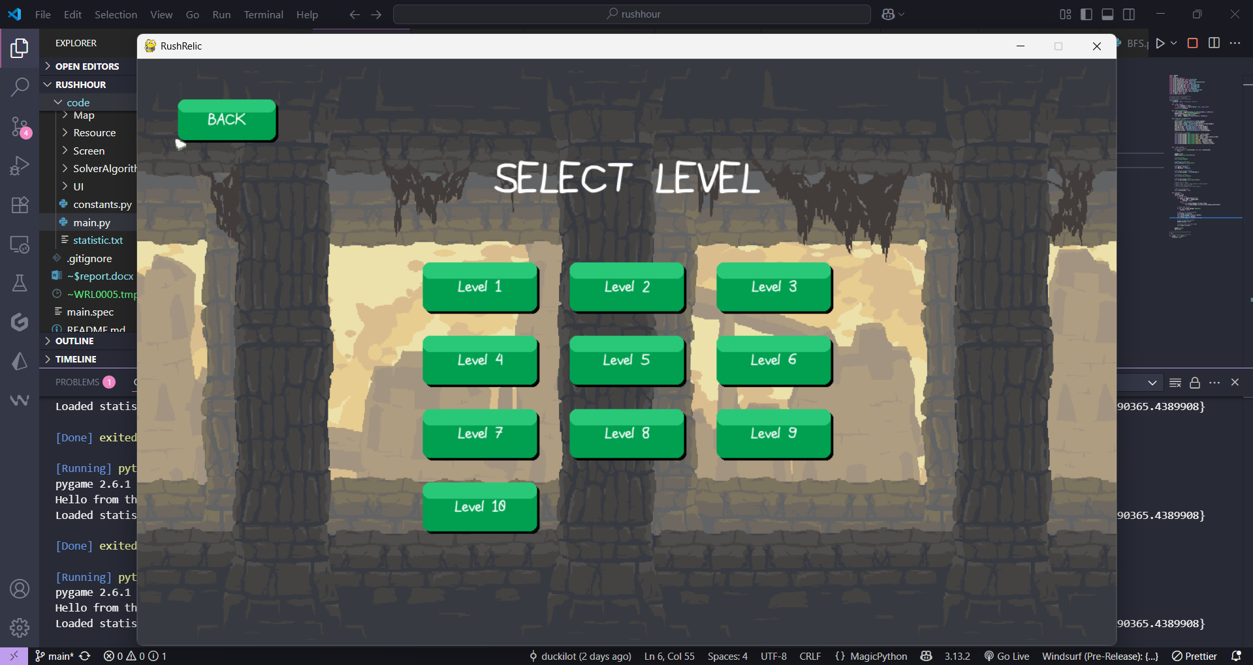

***Image 1.b.i.4****: Select level screen*

* + - 1. **Game screen:** This screen showcases the gameplay in action. You can see this screen when you choose one of the level in level select screen.

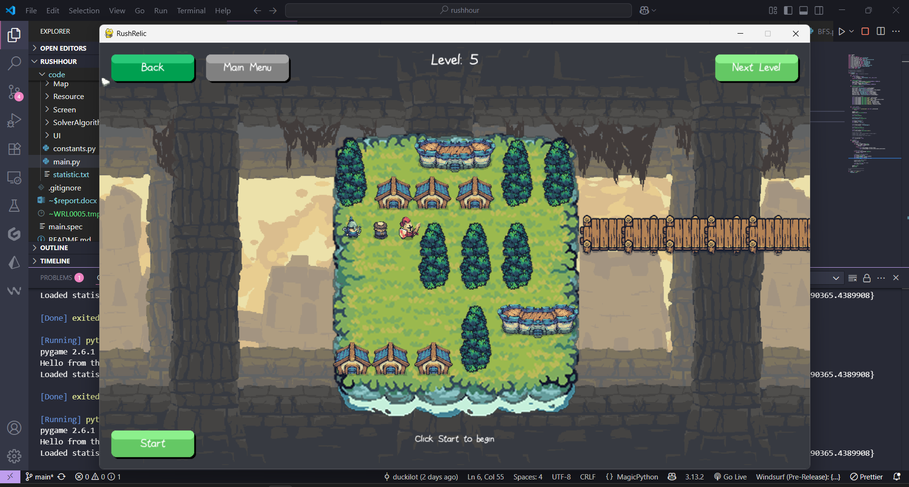

***Image 1.b.i.5****: Game screen level 5*

* + - 1. **Winning screen:** This screen displays a winning animation upon completing a level. It also shows statistics related to the solved level.

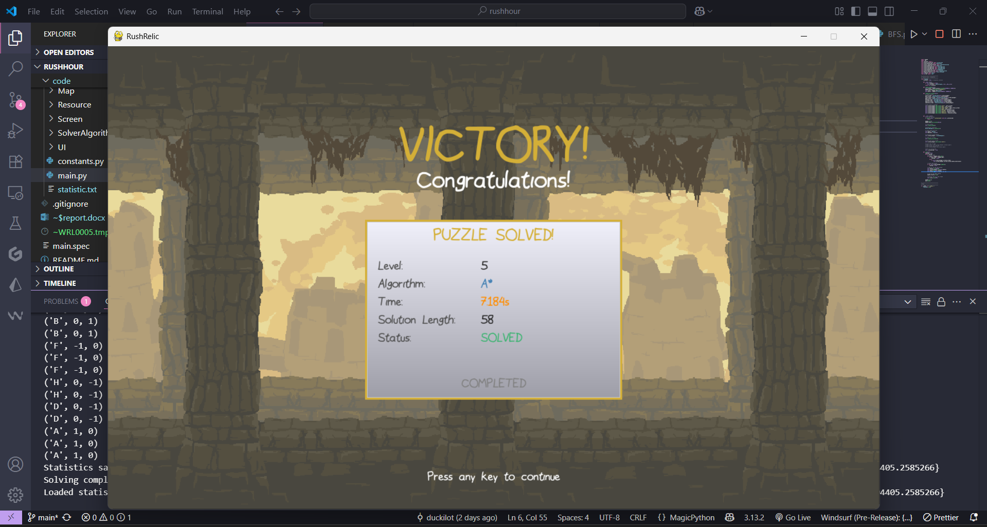

***Image 1.b.i.6****: Winning screen level 5*

* + - 1. **Screens in code:** All screen-related code can be found in the **Screen** folder. More details of the screens code will be displayed in the **Appendix**.

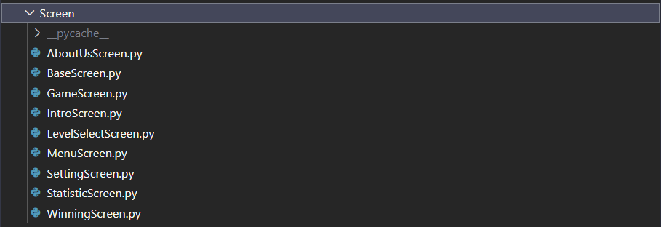

***Image 1.b.i.7****: Screens code*

* + 1. **Gameplays**

Now we focus on the most important screen: the **Game Screen.**

* + - 1. State of the game screen

What “**state**” definition in this situation? In this context, a state refers to the **current condition of the Game Screen**, which determines what components are rendered and how the interface behaves. Each state represents a specific phase in the gameplay flow. The following states are used in the Game Screen:

* **start:** Displays the message “**Click Start to begin**” along with a **Start** button to initiate the game.
* **algorithm_select:** Activated after clicking the Start button. It displays algorithm-related information such as **Total Cost**, **Current Move**, **Nodes Expanded**, **Total Moves**, and prompts like “**Select an Algorithm**”. This state also includes four buttons to select the solving algorithm: BFS, DFS, A*, and UCS.
* **solving:** Triggered after selecting a solving algorithm. It shows **Pause** and **Reset** buttons, while continuously **updating** **statistics** related to the selected algorithm.
* **no_solution:** Occurs when the puzzle has no solution. It briefly shows the message “**No solution for this puzzle**” before returning to the start state. Additionally, a “**Try Again**” button is available for quick resetting without waiting.
  + - 1. Text

There are 2 key types of text elements in the game:

* **Visible Text:** These are text elements that appear only under certain interactions or conditions.
* **Always Display Text:** These are text elements that are constantly shown on the screen.

The text displayed in each state has already been described in the state definitions above.

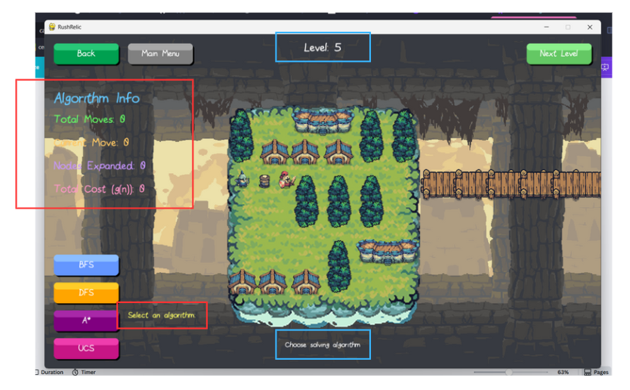

***Image 1.b.ii.1****: The text inside the red box is visible text, meaning it only appears when the user interacts with the interface. In this specific case, the text appears when the “start” button is clicked. Meanwhile, the text “Level 5” is always visible. The text “Choosing solving algorithm” also considered the always appears text bescause it always locates at this position, but just change the text respectively in each state through the function set_text in Text component.*

The code also follows the two text types described above, depending on the current state of the Game Screen. Further details will be provided in the Appendix.

For a quick overview, refer to the pseudo code of the **get_visible_texts** function:

def get_visible_texts(*self*):

        # Always visible

        visible_texts = [*self*.level_text, *self*.status_text]

        # Only visible when algorithm select

        if *self*.ui_state == "algorithm_select":

            visible_texts.append(*self*.instruction_text)

        # Only visible when no solution

        elif *self*.ui_state == "no_solution":

            visible_texts.append(*self*.no_solution_text)

        # Only visible when solving, algorithm select, or no solution

        elif *self*.ui_state in ["solving", "algorithm_select", "no_solution"]:

            visible_texts.extend([

*self*.info_title,

*self*.total_moves_text,

*self*.current_move_text,

*self*.nodes_expanded_text,

*self*.total_cost_text,

            ])

        return visible_texts

* + - 1. Button

Following the same idea as with text, buttons can also be categorized into two types:

* Always-Displayed Buttons.
* Visible Buttons (shown only in specific states).

The buttons displayed in each state have already been described in the state definitions section. Below is the pseudocode that retrieves the list of buttons to be displayed on the screen:

def get_visible_buttons(*self*):

        # Always visible buttons

        visible_buttons = [*self*.back_btn, *self*.next_level_btn, *self*.menu_btn]

        if *self*.ui_state == "start":

            visible_buttons.append(*self*.start_btn)

        elif *self*.ui_state == "algorithm_select":

            visible_buttons.extend([*self*.solve_bfs, *self*.solve_dfs, *self*.solve_astar, *self*.solve_ucs])

        elif *self*.ui_state == "solving":

            visible_buttons.extend([*self*.reset_btn, *self*.pause_btn])

        elif *self*.ui_state == "no_solution":

            visible_buttons.append(*self*.try_again_btn)

        return visible_buttons

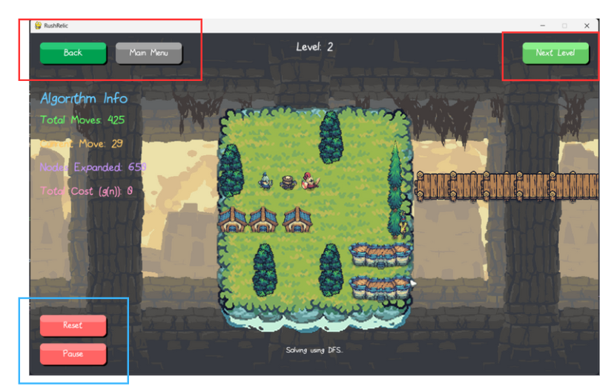

***Image 1.b.ii.2****: The buttons in the blue box are visible buttons, which are displayed only in specific states. Meanwhile, the buttons in the red box are always-displayed buttons, shown consistently regardless of the current state.*

Before moving to the next section, I will briefly explain the functionality of each button (more details of how to implement each function will display in Appendix):

* **Start Button:** When clicked, it transitions the game from the **start** state to the **algorithm_select** state, allowing the player to choose a solving algorithm.
* **Algorithm Selection Buttons (BFS, DFS, A*, UCS):** These buttons allow the player to choose a specific algorithm for solving the puzzle. Clicking one of these buttons also transitions the game to the solving state.
* **Reset and Pause Buttons** (in the solving state, see Image 1.b.ii.2):
  + **Reset:** Resets the map and restarts the visualization of the algorithm.
  + **Pause**: Temporarily pauses or resumes the algorithm’s execution.
* **Try Again Button:** Appears when no solution is found for the current puzzle. This button serves a similar purpose as Reset—restarting the level immediately without waiting.
* **Persistent Buttons (Always Displayed):**
  + **Back:** Returns to the level selection screen.
  + **Next Level:** Proceeds to the next level.
  + **Main Menu**: Returns to the main menu.

Here is the pseudo code of the handle_event function to handle the button click events in the Game screen:

if *event*.type == pygame.MOUSEBUTTONDOWN:

            if *self*.ui_state == "start":

                if *self*.start_btn.hit(*event*.pos):

*self*.ui_state = "algorithm_select"

            elif *self*.ui_state == "algorithm_select":

                if *self*.solve_bfs.hit(*event*.pos):

*self*.map.start_solving("BFS")

*self*.algorithm_text.set_text("Algorithm: BFS")

*self*.ui_state = "solving"

                elif *self*.solve_dfs.hit(*event*.pos):

*handle similar to bfs*

                elif *self*.solve_astar.hit(*event*.pos):

*handle similar to bfs*

                elif *self*.solve_ucs.hit(*event*.pos):

*handle similar to bfs*

            elif *self*.ui_state == "solving":

                if *self*.reset_btn.hit(*event*.pos):

*self*.reset_to_start()

                elif *self*.pause_btn.hit(*event*.pos):

*self*.is_paused = not *self*.is_paused

                    if *self*.is_paused:

*self*.pause_btn.set_text("Continue")

*self*.map.pause_solving()

                    else:

*self*.pause_btn.set_text("Pause")

*self*.map.resume_solving()

            elif *self*.ui_state == "no_solution":

                if *self*.try_again_btn.hit(*event*.pos):

*self*.ui_state = "algorithm_select"

            # Always check these always appearing buttons

            if *self*.back_btn.hit(*event*.pos):

*self*.screen_manager.set_screen('level_select')

            elif *self*.next_level_btn.hit(*event*.pos):

*self*.next_level()

            elif *self*.menu_btn.hit(*event*.pos):

*self*.screen_manager.set_screen('menu')

            else:

# do it when interact with the car

*self*.map.handle_mouse_down(*event*.pos)

* + - 1. Gameplay

I will leave this part for you to enjoy the gameplay. After clicking one of the four solving buttons—DFS, BFS, A*, or UCS—the vehicles will automatically move according to the solution generated by the selected algorithm.

The list of moves which returned from the solver will be the resource for the animation, more detailed of move definitions will be explained later, this part you can understand a move includes the new direction and the name of the car prepared to move. Here are the peseudo code of the function **update_solving**:

# tuple type ('A', dx, dy)

vehicle_name, dx, dy = move

# find index of vehicle by name

for idx, v in enumerate(*self*.vehicles):

if v.name == vehicle_name:

v.x += dx

v.y += dy

After completing the animation of the solution steps, the characters proceed to the winning screen and celebrate. At the same time, key information such as **total cost** and **execution time** is saved into a file named **statistic.txt** in **json** format. This file is later reused to display the corresponding data on the winning screen. Below is a sample of the statistic.txt file:

{

  "level": 9,

  "algorithm": "A*",

  "time_executed": 6.212014436721802, # this is the time of the animation (not the time of the solver execution)

  "nodes_expanded": 820,

  "solution_length": 54,

  "solved": true,

  "timestamp": 1752298437.0997696

}

* 1. **Design system and Design pattern**
     1. **System Class** 
        1. Class Program

The game is built using **pygame**, a Python library for 2D game development that supports graphics rendering, user input, and sound.

The main function is the core of the system, structured as a continuous game loop. Each loop **clears the screen**, **processes input**, **updates object states**, and **redraws the frame**.

To ensure only one controller instance, the **Singleton** pattern is applied to main.

Rendering uses **double buffering**: objects are first drawn to a **back buffer**, then flipped to the screen for smooth display and reduced flickering.

Peseudo code for the main loop:

while running:

            # RECEIVE EVENT

*self*.screen_manager.current_screen.handle_event(event)

            # UPDATE NEW STATUS

            if not *self*.screen_manager.update():

                running = False

            # DRAW ALL IN THE BACK BUFFER

*self*.buffer.fill(BLACK)

*self*.screen_manager.draw(*self*.buffer)

*self*.screen.blit(*self*.buffer, (0, 0))

            # FLIP TO THE FRONT BUFFER

            pygame.display.flip()

            # WAITING TIME TILL NEXT FRAME

*self*.clock.tick(FPS)

* + - 1. Class Screen

This class applies the **State design pattern** to manage different UI screens. New screens can be added using the **addScreen(‘hello_screen’)** method, and the current screen can be switched using **setScreen(‘hello_screen’)**.

Since this class is responsible for rendering on the screen, it must include three main functions: **draw**, **update**, and **handle_event**. Common functions that are shared across screens are placed in the BaseScreen class, such as the draw_background function.

* + - 1. Class Solver

The Solver class is a core component responsible for implementing the game's solving algorithms. It includes a **BaseSolver** class that contains shared logic and helper functions used across all strategies, ensuring consistency and reducing code duplication.

To support scalability, a **SolverFactory** is used to create solver instances dynamically, allowing new algorithms to be added with minimal changes.

The system adopts the **Strategy design pattern**, enabling the program to switch between different solving algorithms (e.g., BFS, DFS) at runtime. Each strategy is encapsulated in a separate class, making the design modular, extensible, and easy to maintain.

Here is the peseudo code of the handing choosing strategy in SolverFactory:

def create_strategy(*strategy_name*, *map_obj*, *max_time*=30):

        if *strategy_name* == 'DFS':

            return DFSStrategy(*map_obj*, *max_time*)

        elif *strategy_name* == 'BFS':

            return BFSStrategy(*map_obj*, *max_time*)

        elif *strategy_name* == 'UCS':

            return UCSStrategy(*map_obj*, *max_time*)

        elif *strategy_name* == 'A*':

            return AStarStrategy(*map_obj*, *max_time*)

        else:

            raise ValueError(f"Invalid strategy name: {*strategy_name*}")

Here is the peseudo code of how to using this design pattern in function start_solving:

def start_solving(*self*, *nameAlgo*: str):

        if not *self*.solving:

            strategy = StrategyFactory.create_strategy(*nameAlgo*, *self*)

*self*.solver = PuzzleSolver(*self*, strategy)

            solution = *self*.solver.solve()

* + - 1. Class relative to UI

This module contains classes such as **Button**, **Text**, **Font**, **Mouse**, **StatisticBoard** which are responsible for rendering the game’s user interface.

The game exclusively ues the **Vinizinho** font for all text rendering, ensuring a consistent visual style.

The **Button** class applies the **State** design pattern to manage its visual states, including default, hover, and click. This approach improves the clarity and maintainability of UI behavior.

The **StatisticBoard** is only used for display the statistic of the solution by reading the statistic.txt.

These component will display on the screen, therefore all of these class will all have the method such as **draw**, **update**, **handle_event** (similar to the main).

More detail of ẻach class and its variables and method will be showed in Appendix.

* + - 1. Class AudioManager

AudioManager is a Singleton class responsible for handling all audio in the game, including background music and sound effects (e.g., mouse clicks).

It is designed with multithreading support to ensure that audio playback does not interrupt other game actions or reduce performance.

To enhance the user experience, the game includes a settings screen where players can toggle music on/off and adjust volume levels.

Example of the using multithreading:

def play_sound_effect(*self*, *effect_name*, *volume_multiplier*=1.0):

        def play_sound():

                sound = *self*.loaded_sounds[*effect_name*]

                sound.set_volume(*self*.sfx_volume * *volume_multiplier*)

                sound.play()

        # use thread not to block game

*self*.audio_thread = threading.Thread(*target*=play_sound)

*self*.audio_thread.start()

* + - 1. Class ResourceManager

ResourceManager is a class responsible for initializing and managing game assets, especially images.

There are two types of images handled: static images and sprites.

* Static images are used for non-animated objects such as maps and backgrounds.
* Sprite images are used for animated elements like the Character class.

This centralized asset management improves performance, memory usage, and makes resource loading more consistent across the game.

Main command using for load resources:

image = pygame.image.load(*path*).convert_alpha() 🡪 save images

ResourceManager._images[*name*] = image

Sheet = pygame.image.load(*path*).convert_alpha() 🡪 save frames

frames = [sheet.subsurface(pygame.Rect(i * *frame_width*, 0, *frame_width*, *frame_height*)) for i in range(*num_frames*)]

ResourceManager._images[*name*] = frames

The main command used to work with images or animation frames is the get_image function. It retrieves the identifier of each image from a dictionary managed by the ResourceManager class. For example:

img = ResourceManager().get_image(f'map_{i}_statistic')

* + - 1. Other class
* **Character Class:** To enhance visual appeal, the **target car** is represented by three characters: **Archer**, **Monk**, and **Warrior**, each with three main animations: **idle**, **run**, and **perform_skill**. The class is implemented following the State Design Pattern, where each state determines which animation is displayed.
* **Animation Class:** Designed to handle character animations. In this project, it is used exclusively for the Character class to control its animations. The full name of this class is **AnimationStrategy**, as the project may scale to include other types of animations. The Strategy Design Pattern allows flexible animation selection depending on the developer's needs. (Strategy also apply to the character class: each character performs the different skill).
* **Comparison Class:** This class supports the Statistic Screen. When running the compare.py file independently, it generates comparison metrics for all solving algorithms. The Comparison class works similarly to the Solver class, using various algorithms to compute values. These results also serve as data for the metric evaluation section (Section 4).

The Appendix will include detailed explanations of how the above classes work. Now, we move on to two important classes: Map and Vehicle.

* + 1. **Core Game Classes: Map and Vehicle**

This section defines two essential classes — **Vehicle** and **Map** — which directly affect the game logic and solving process.

* + - 1. Class Vehicle

The Vehicle class represents a car on the map and is defined by five key input parameters:

* **orient**: the orientation of the vehicle (horizontal or vertical)
* **len**: the length of the vehicle
* **x, y**: the vehicle’s coordinates on the grid
* **name**: the name/identifier of the vehicle
* **key**: support get image through key

A notable method of this class is:

* **copy**(): creates a deep copy of the vehicle, which is essential for generating new states during the solving process.
  + - 1. Map

The Map class manages the game state and solving logic for each level. Key input attributes include:

* **initial_vehicles**: an array of Vehicle instances loaded from a map.txt file.
* **current_level**: the current level ID used to load the corresponding map file.
* **solver**: the selected algorithm for solving the level (through Strategy Solver).
* **solving**: a boolean flag indicating whether the level is currently being solved.
* **solution_moves**: total number of moves in the computed solution.
* **node_expanded**: total states are visited.
* **total_cost**: total cost of the algorithms.
* **current_move_index**: used to manage pause/resume functionality.
* **move_timer**: tracks how long the solver takes to finish.
* **move_delay**: controls the animation speed for each move.
* **list_solver**: stores the names of visited vehicles (used for visualizing or debugging).

Important methods include:

* **load_level_data_from_file**(): This function reads level data from a file based on the current_level. It is used to load the corresponding game map. For example, to load level 1, the function reads the file 1.txt located in the map folder. The file txt format follow the class Vehicle, for instant:

target h 2 0 2 A

v2 v 2 0 0 B

v2 h 2 2 0 C

v2 v 2 4 0 D

v2 v 2 5 0 E

v2 v 2 2 2 G

v2 v 2 3 2 H

v2 v 2 4 2 I

v2 v 2 3 4 J

v2 h 2 4 4 K

v3 h 3 1 1 F

v3 h 3 0 5 P

* **reset**(): resets the map to its initial state.
* **update**(): progresses the solving state frame by frame.
* **start_solving**(): selects and runs the appropriate algorithm (e.g., if BFS is selected, it will use BFSStrategy to solve the puzzle; the map instance itself is passed as the input).
* **print_solution**(): displays the list of moves that solve the level.
* **handle_pause**(): toggles between pause and resume using the solving flag.

As both the Vehicle and Map classes are rendered on the screen, they also implement the core functions: **draw**, **update**, and **handle_event**.

1. **Description of the Maps** 
   1. **Foudational Elements in a Map**

Each map in ***RushRelic*** is designed based on a consistent set of foundational elements that define the gameplay experience. These include:

* **Vehicles List**: As mentioned earlier, this list is read from a .txt file. It contains the data for all vehicles in the level. This report use the format from the txt file to display the information of these car. Specially, each line can understand as:

vehicle = Vehicle(image_key, direction, length, row, col, name)

Example:

target h 2 2 2 A <=====> Vehicle(“target”, “h”, 2, 2, 2, “A”)

which means: target (name A) places at position (2, 2) from the map with the direction <h = horizontal> with length = 2

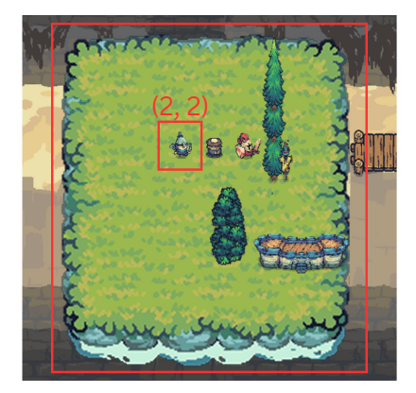

***Image 2.a.1****: The target vehicle (name as A) locates at position (2, 2) with horizontal direction (its length equal to 2 cells).*

* **Exit Placement**: The exit is positioned horizontally aligned with the target vehicle.
  1. **Map Details**

* + 1. **Map 1**

This map can be considered the easiest one. Below are the properties of Map 1:

* Vehicles List (in file txt format):

target h 2 2 2 A

v3 v 3 4 0 B

v2 v 2 3 3 C

v2 h 2 4 4 D

* Image of the map 1:

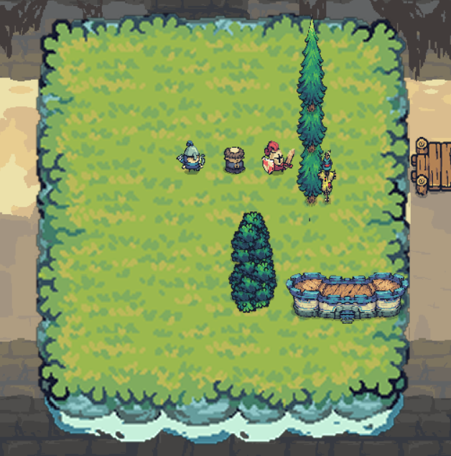

* This map is adapted from **CokoGames** (level 1) and includes a total of 4 vehicles. It is designed as a simple map to evaluate the performance of the four algorithms under a low-vehicle scenario.
* You can explore **CokoGames** in the link in reference section.
  + 1. **Map 2**
* Vehicles List (in file txt format):

target h 2 0 2 A

v2 v 2 0 0 B

v2 v 2 3 0 C

v2 v 2 3 2 D

v3 h 3 0 3 E

v2 v 2 1 4 F

v2 h 2 2 4 G

v2 h 2 2 5 H

v3 v 3 5 2 I

* Image of the map 2:

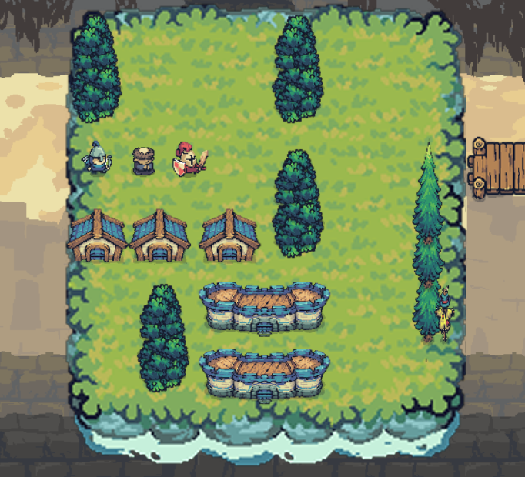

* This map is also adapted from **CokoGames** (level 17) with more complicated map and takes more moves.

* + 1. **Map 3**
* Vehicles List (in file txt format):

target h 2 0 2 A

v2 v 2 2 1 B

v3 v 3 3 1 C

v3 v 3 4 1 D

v2 h 2 0 3 E

v2 v 2 1 4 F

v2 h 2 2 5 G

v2 v 2 2 3 H

* Image of the map 3:

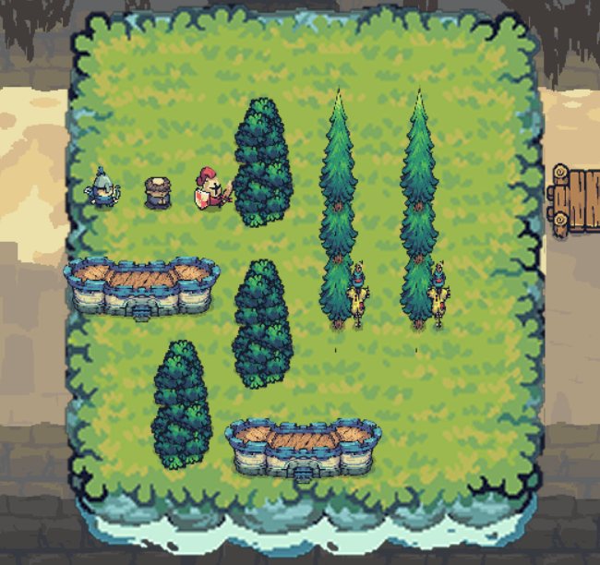

* Similar to the map 1 and map 2, this map take the level 12 of the **CokoGames.**
  + 1. **Map 4**
* Vehicles List (in file txt format):

target h 2 3 2 A

v2 h 2 0 0 B

v2 h 2 0 1 C

v2 v 2 1 2 D

v2 v 2 0 3 E

v2 h 2 1 4 F

v2 v 2 3 3 G

v2 h 2 4 3 O

v2 h 2 4 4 U

v3 v 3 2 0 J

v3 v 3 5 0 K

v3 h 3 1 5 L

* Image of the map 4:

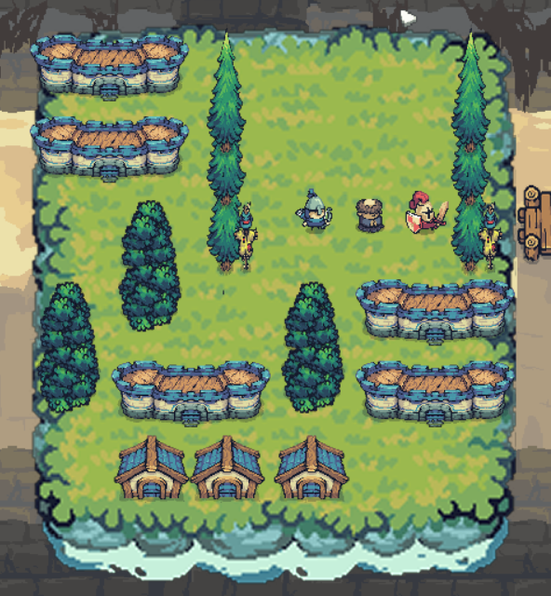

* This map take the final level (level 50) of the **CokoGames.** The process of choosing a map due to the harder level which taken from the webs.
  + 1. **Map 5**
* Vehicles List (in file txt format):

target h 2 0 2 A

v2 v 2 0 0 B

v2 h 2 2 0 C

v2 v 2 4 0 D

v2 v 2 5 0 E

v2 v 2 2 2 G

v2 v 2 3 2 H

v2 v 2 4 2 I

v2 v 2 3 4 J

v2 h 2 4 4 K

v3 h 3 1 1 F

v3 h 3 0 5 P

* Image of the map 5:

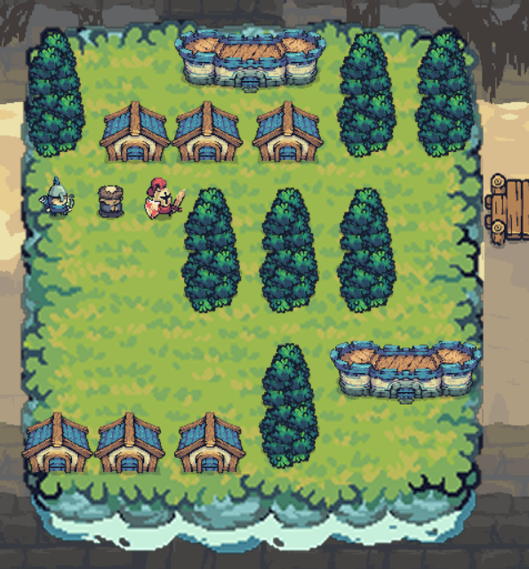

* More challenging puzzles are no longer available on **CokoGames**, so we turned to a better resource: **Michael Fogleman's collection** (watch more in reference section). From this point onward, we select maps from his website, which offer more complex solutions and a greater number of states to explore.
  + 1. **Map 6**
* Vehicles List (in file txt format):

target h 2 3 2 A

v2 h 2 1 0 B

v2 v 2 4 0 C

v2 v 2 1 1 D

v2 v 2 2 1 E

v2 v 2 3 3 F

v2 v 2 2 4 G

v2 h 2 4 4 H

v2 h 2 3 5 I

v2 h 2 0 5 J

v3 v 3 0 0 K

v3 v 3 5 1 L

v3 h 3 0 3 Z

* Image of the map 6:

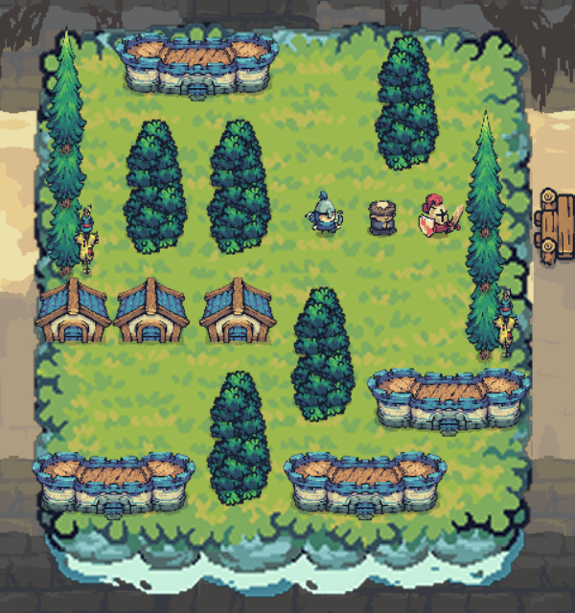

* + 1. **Map 7**
* Vehicles List (in file txt format):

target h 2 0 2 A

v2 v 2 0 0 B

v2 h 2 2 1 C

v2 v 2 2 2 D

v2 v 2 3 2 E

v2 h 2 0 3 F

v2 v 2 3 4 G

v2 h 2 4 4 H

v3 h 3 1 0 I

v3 v 3 4 0 J

v2 h 2 0 5 O

* Image of the map 7:

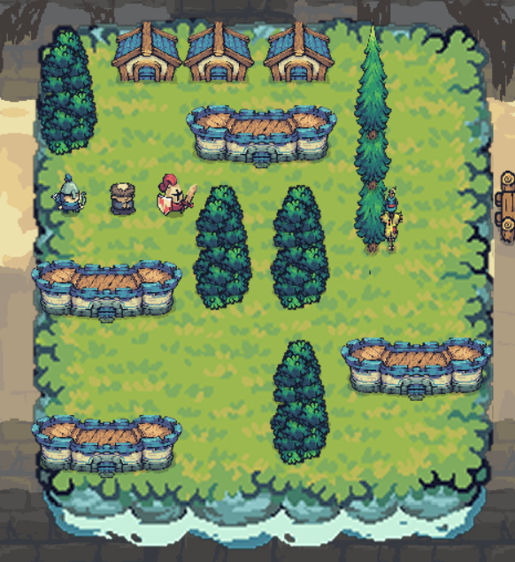

* + 1. **Map 8**
* Vehicles List (in file txt format):

target h 2 1 2 A

v2 v 2 0 0 B

v2 v 2 1 0 C

v2 h 2 2 0 E

v2 h 2 2 1 F

v2 v 2 4 0 G

v2 v 2 5 0 H

v2 v 2 3 2 I

v2 v 2 5 2 J

v2 v 2 2 3 K

v2 h 2 0 5 L

v3 v 3 0 2 Q

v3 h 3 3 4 O

v3 h 3 2 5 P

* Image of the map 8:

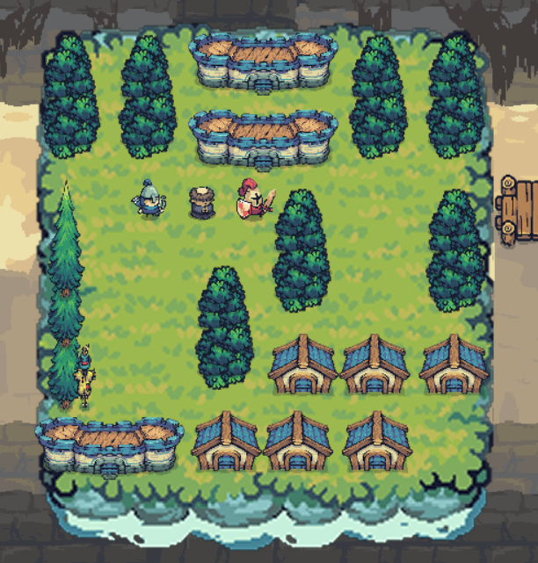

* + 1. **Map 9**
* Vehicles List (in file txt format):

target h 2 3 2 A

v2 h 2 0 0 B

v2 v 2 5 0 C

v2 v 2 0 1 D

v2 h 2 3 1 E

v2 h 2 0 3 F

v2 h 2 0 4 G

v2 h 2 2 3 H

v2 v 2 2 4 I

v2 v 2 4 3 J

v3 h 3 2 0 K

v3 v 3 5 2 L

v3 h 3 3 5 Q

* Image of the map 9:

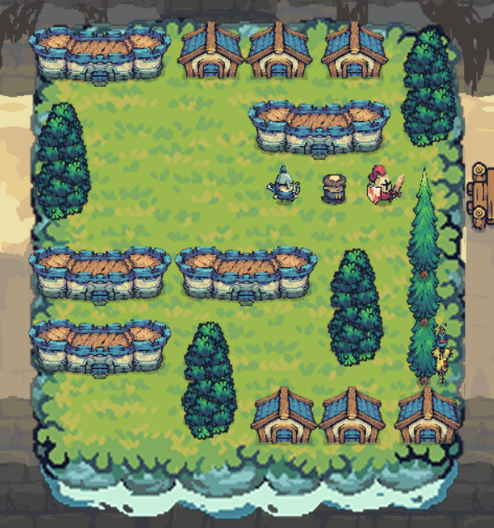

* + 1. **Map 10**
* Vehicles List (in file txt format):

target h 2 0 2 A

v2 v 2 2 0 B

v2 v 2 3 1 C

v2 v 2 2 2 D

v2 h 2 0 3 E

v2 h 2 3 3 F

v2 v 2 0 4 G

v2 v 2 1 4 H

v2 h 2 2 4 I

v2 h 2 2 5 J

v3 h 3 3 0 K

v3 v 3 5 2 L

* Image of the map 10:

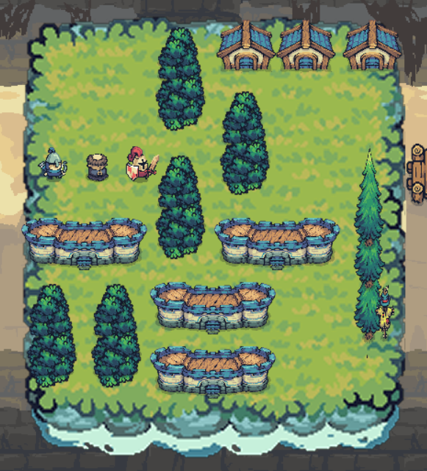

1. **Search Algorithm Description** 
   1. **Input and Output Specification**
   2. **State Representation and Visited Table**
   3. **Solvers explaination**
      1. **BFS Solver**
      2. **DFS Solver**
      3. **UCS Solver**
      4. **A* Solver**
2. **Experiments** 
   1. **Design a comparison Tool: Comparison Class**

As previously mentioned, this class is responsible for generating the performance metrics used for evaluating algorithms. It is implemented in the **compare.py** file.

Before proceeding with the implementation, we first define the metrics used for comparison and evaluation. In total, eight metrics are calculated (default k = 3):

* **Average Execution Time:** Time taken over k runs.
* **Average Memory Usage:** Memory consumed across k runs.
* **Average Number of States Explored:** The total number of states visited, averaged over k runs.
* **Average Total Cost:** The cost of reaching the goal, averaged over k runs.
* **Average Solution Length:** The number of steps in the solution path, averaged over k runs.
* **Success Rate:** Number of successful runs (out of k).
* **Minimum Execution Time:** The shortest run time among the k runs.
* **Maximum Execution Time:** The longest run time among the k runs.

These variables are managed inside a class named **PerformanceMetrics**, which stores each metric as a list of values collected during the three runs. The average is then computed using the simple formula: **sum(metric) / len(metric), max(metric), min(metric).**

Similar to the **Solver** class, we apply both the **Factory Pattern** and the **Strategy Pattern** to allow flexible selection and execution of algorithms.

The core class responsible for comparison is **AlgorithmComparison**. It contains the method **compare_all_algorithms()**, which iterates through all four algorithms **(BFS, DFS, A*, UCS)** and evaluates each one using the method **measure_algorithm_performance().**

Since each algorithm is executed k times for accurate averaging, we define an additional helper method: **measure_single_run**(). This method uses the Strategy Design Pattern to dynamically select the appropriate solver based on the algorithm's name and then measures several key performance metrics.

**The Four Main Metrics Measured**

* **Execution Time**: Measured by capturing the current timestamp before and after the solving process, then calculating the difference. This gives the total time taken for a single run.
* **Memory Usage**: Measured using the tracemalloc module. Specifically, we use the **get_traced_memory()** function to retrieve the peak memory allocated during the execution. This metric helps track memory efficiency.
* **Total Cost:** Returned directly from the solver. It represents the total cost of reaching the goal in the solution path.
* **Number of States Explored:** Also returned from the solver. It indicates how many nodes or game states were expanded during the search process.
* **Solution Length:** Obviously calculatble when we have the list of moves

After collecting these metrics, they are stored in a **PerformanceMetrics** class, which acts as a structured container for holding and accessing these results.

**Reporting the Results**

To support the reporting and analysis process, the system generates three types of reports:

* **Text Report (.txt):** Contains human-readable summaries of all performance metrics for the current map.
* **CSV Report (.csv):** Stores the data in tabular format, making it easy to view in Excel or import into data analysis tools.
* **Chart Report (.png)**: Visualizes the data using matplotlib, allowing quick comparisons across algorithms through bar or line charts.

To handle these three report types efficiently, the Strategy Design Pattern is again applied. A base class **ReportGenerator** is defined with an abstract method **generate_report().** Three concrete subclasses implement this method for their respective formats:

* **TextReportGenerator:** Generates .txt reports.
* **CSVReportGenerator:** Generates .csv reports.
* **ChartGenerator:** Generates visual charts using matplotlib.

Each subclass is responsible for writing or rendering the output according to its specific format.

After carefully designing the tools, it is now time to evaluate the performance of each algorithm. We will focus on the five most important metrics mentioned earlier:

* Solution Length
* Search Time
* Memory Usage
* Expanded Node

Each of these metrics provides a different perspective on the efficiency and behavior of the algorithms. In the following sections, we will analyze and compare these metrics across all algorithms using the generated reports.

* 1. **Solution length**
     1. **Measurements**

In terms of solution length, **DFS (Depth-First Search)** tends to produce significantly longer paths compared to the other three algorithms. In some cases, the solution length generated by DFS is **three to even ten times longer** than those produced by BFS, UCS, and A*.

On the other hand, **BFS, UCS, and A\*** generally yield **similar solution lengths**, which are much more optimal and consistent.

* + 1. **Visualizations**

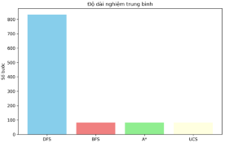

***Image 4.b.ii.1****: Bar chart of the solution’s length*

* + 1. **Insight**

This observation can be explained as follows:

* **DFS (Depth-First Search):** DFS explores paths deeply before backtracking, often committing to a long path before realizing it is suboptimal. If the algorithm starts by expanding an unpromising vehicle or path, it is likely to continue along a similarly poor route, leading to unnecessarily long solutions.
* **BFS:** Although BFS doesn't perform cost calculations like UCS or A*, it still manages to produce solutions with similar move counts. This is because BFS explores all states level by level, and in many cases, the shortest path in terms of moves (not cost) is found early. Interestingly, many of the states dequeued in BFS coincidentally have the same cost as those prioritized by UCS or A*. **Whether this is a matter of luck or structural similarity in the problem space is debatable—but the results are comparable.**
* **UCS and A*:** These algorithms explicitly consider path cost.
  + UCS uses g(n)—the actual cost from the start to node n.
  + A* uses f(n) = g(n) + h(n), combining actual cost and a heuristic estimate. In many practical scenarios (especially with good heuristics), h(n) approximates 0 or small, leading A*'s behavior to be very similar to UCS. Therefore, the solution length and cost are often the same or very close.
  1. **Search Time**
     1. **Measurements**

In contrast to the solution length comparison, **DFS is the fastest algorithm in terms of execution time**.

On the other hand, the **execution times of BFS, UCS, and A\*** are relatively similar. However, depending on the complexity and structure of each map, one algorithm may take slightly longer than the others.

* + 1. **Visualizations**

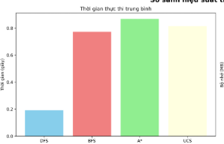

***Image 4.c.ii.1****: Bar chart of the solution’s time execution*

* + 1. **Insight**

This observation can be explained as follows:

* **DFS:** As mentioned in the solution length analysis, DFS explores deeply and quickly backtracks when hitting dead ends. Although it may take more steps overall, it avoids complex calculations and operates with a simple stack-based mechanism.
* **BFS:** While BFS performs a level-order traversal and does not involve cost computation, it still takes **noticeably more time than DFS**. This can be attributed to the overhead of **maintaining a large queue and checking for visited states across all levels**. These internal operations introduce hidden computational costs that slow it down.
* **UCS and A*:** These two algorithms require **additional calculations** for each state, so it obviously take slower time execution.
  1. **Memory Usage**
     1. **Measurements & Insight**

This is a metric that proves difficult to evaluate definitively. Depending on the structure and complexity of each map, memory consumption varies significantly across algorithms. In this situation, **memory usage is not considered a reliable criterion for determining which algorithm is more optimal** in this particular project.

* + 1. **Visualizations**

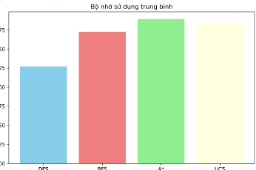

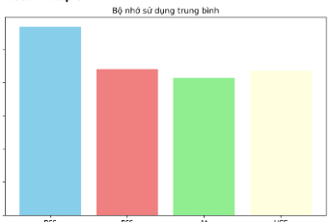

***Image 4.d.ii.1 & Image 4.d.ii.2****: Bar charts illustrating execution time across algorithms. In the first chart, A* exhibits the highest execution time, indicating suboptimal performance. Conversely, the second chart presents an inverse result, with A* performing more efficiently. Similar contrasting behavior is observed with DFS across the two maps.*

* 1. **Expanded Node** 
     1. **Measurements**

The results show that **DFS consistently outperforms the other three algorithms in terms of the number of expanded nodes**, often exploring significantly fewer states. Meanwhile, **BFS, UCS, and A\*** exhibit similar performance in this metric. This trend aligns closely with the execution time metric, as fewer expanded nodes often correlate with faster computation.

* + 1. **Visualizations**

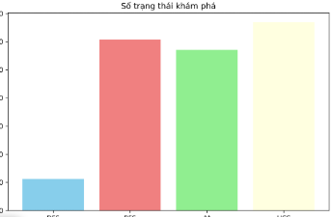

***Image 4.e.ii.1****: Bar chart of the solution’s total node expanded*

* + 1. **Insight**

This observation can be explained similarly to the execution time metric. **DFS**, due to its backtracking nature, tends to revisit fewer unique states. It often continues along a single path until a solution is found or failure is encountered, which reduces the need to explore the broader state space.

In contrast, the other three algorithms evaluate a much larger number of states:

* **BFS** explores the search space level by level. At each level, it expands all possible child states, many of which are ultimately unnecessary or unused in the final solution.
* **UCS and A\*** perform cost-based evaluation. To compute accurate g(n) or f(n) values, they must explore a wider range of states, including those that may not lie on the optimal path. This naturally increases the number of nodes expanded during the search.
  1. **Summary insight**

If the primary goal is **speed and minimizing the number of expanded nodes**, then **DFS** emerges as the optimal choice. However, if the objective is to find the **shortest and most optimal solution**, then **A\*** would be the recommended algorithm. While A* may not always outperform other algorithms in every scenario, as shown in the charts, it tends to produce better solutions when a well-designed heuristic is used.

On the other hand, if one is concerned with **memory efficiency**, this project **does not provide conclusive evidence to determine which algorithm is superior in that regard**.

1. **Project Plan and Task Distribution** 
   1. **Project Plan**

**Project Timeline (28 Days)**

The development process was divided into the following phases:

* **Phase 1 (7 days):** Researching algorithms and collecting suitable puzzle maps.
* **Phase 2 (7 days):** Designing graphics and implementing core system components and related classes.
* **Phase 3 (3 days):** Building a preliminary “main” version of the game.
* **Phase 4 (3 days):** Finalizing the system structure, clearly defining algorithm input and output to begin testing.
* **Phase 5 (7 days):** Implementing and integrating all four search algorithms (DFS, BFS, UCS, A*).
* **Phase 6 (1 day):** Generating statistics and completing the project report and video youtube game.

**Evaluation**

The reporting phase was extremely time-constrained, which impacted the depth of analysis. Additionally, the research and system design phases took longer than initially expected, while the project do not require too much.

* 1. **Task Distribution**

**Member Role**

* **Trần Hải Đức – Team Leader & Project Manager:** Responsible for overall coordination, system design, and project planning.
* **Huỳnh Minh Đoàn – Graphic Designer:** In charge of all visual elements, UI assets, and character/environment graphics.
* **Trần Thái Bảo** **– Sound Designer & Algorithm Analyst:** Responsible for game sound effects and conducting comparisons between algorithms.
* **Trần Sở Vinh – Tester & Algorithm Developer:** Responsible for implementing the main solving algorithms and performing extensive testing.

**Task Distribution**

|  |  |  |
| --- | --- | --- |
| Member | Task | Contribution percentage |
| **Trần Hải Đức – 23127173** | * Design system: main, class Program, Text, Font, Resource, Screen, Vehicle, Map, Button, Animation, Character. * Merge code member * Write report section 1, 2, 4, 5, 6 * Design GUI, UI * Support algorithm: DFS | 100% |
| Huỳnh Minh Đoàn - 23127347 | * Support design system: class Map * Suport design graphic * Support algorithm: UCS * Write report section 7, 8 | 90% |
| Trần Thái Bảo - 23127160 | * Support design system: Class StatisticBoard * Sound design: Class Audio, find sounds resources * Algorithm Analyse: Class Comparison * Video game making * Support algorithm: BFS | 100% |
| Trần Sở Vinh – 23127282 | * Code algorithm: A* * Merge code algorithm: BFS, DFS, UCS * Write report section 3 | 100% |

1. **References**

[1] Vinizinho, Vini Fonts, [Online]. Available: <https://vinizinho.itch.io/vini-fonts>

[2] M. Fogleman, Rush Hour Game Collection, [Online]. Available: <https://www.michaelfogleman.com/rush/>

[3] CokoGames, Rush Hour Game, [Online]. Available: <https://www.cokogames.com/rush-hour/play/>

[4] Szadi Art, Background: Desert Mountains, [Online]. Available: <https://szadiart.itch.io/background-desert-mountains>

[5] Pixabay, Free Images and Videos, [Online]. Available: <https://pixabay.com>

1. **Apendix**
   1. **Class Font**

This class is a lightweight wrapper around pygame.font.Font that handles custom font loading and falls back to a system font if the specified file is missing.

**__init__(self, size, path="assets/fonts/vinizinho.ttf")**

Main attribute: Initializes a font object with a given size and font file path.

Parameters:

* size (*int*): Font size in pixels.
* path (*str*): Path to a .ttf font file (default is "assets/fonts/vinizinho.ttf").

**Behavior**:

* If the file at path exists, it loads the font from that path.
* If not, it prints a warning and uses the system's default "arial" font instead.

**render(self, text, color=(255, 255, 255))**

Main attribute: Create a surface from a text with the initialized font.

Parameters:

text: text string to display.

color: text color (RGB tuple), default is white (255, 255, 255).

Returns: pygame.Surface containing the rendered text (anti-aliased).

* 1. **Class Text**

This class handles rendering and displaying text in a Pygame application. It allows positioning, updating, and re-rendering text dynamically, with optional center alignment.

**__init__(self, text, color, pos, font=None, center=True)**

Main attribute: Creates a text object with specific content, style, and position.

Parameters:

text (str): The string to display.

color (tuple[int, int, int]): RGB color of the text.

pos (tuple[int, int]): Position on the screen.

font (Font): A Font object (custom wrapper around pygame.font.Font).

center (bool): If True, position is treated as center; otherwise, it's the top-left corner.

Behavior:

Render the initial text.

Sets up its bounding rect (either centered or top-left aligned).

**draw(self, surface)**

Main attribute: Draws the rendered text onto the given surface (usually your game screen)

Parameters

surface: The Pygame surface to draw on (e.g. screen)

**set_text(self, new_text)**

Main attribute: Updates the text content and re-renders it.

Parameters:

new_text (*str*): The new text to display.

Note: It keeps the current alignment (centered or top-left).

**set_position(self, new_pos)**

Main attribute: Moves the text to a new screen position.

Parameters:

new_pos (*tuple[int, int]*): New screen coordinates.

* 1. **Class Button**

This class represents a clickable button with hover effects, text rendering, and customizable visuals. It is commonly used in menu screens, settings, and dialogs.

**__init__(self, text, pos, width=140, height=50, color=(0, 160, 80))**

Main attribute: Creates a new button with:

* text: the label shown on the button.
* pos: (x, y) position (top-left of the button).
* width/height: size of the button.
* color: base RGB color (default: greenish).

Initial setup includes:

* Creating a pygame.Rect for positioning and collision.
* Creating a Text object centered inside the button.
* Preparing a hover color (lighter than base).

**handle_event(self, event)**

Main attribute: Checks whether the mouse is hovering over the button during the event loop.

**update(self)**

Main attribute: Keeps the text centered within the button if position or size changes.

**draw(self, surface)**

Main attribute: Draws the button with:

* A shadow for depth.
* A colored base (hovered or normal).
* A highlight strip at the top for a glossy look.
* The text label.

**hit(self, mouse_pos)**

Main attribute: Returns True if the mouse position is within the button's area — useful for clicks.

**set_text(self, new_text)**

Main attribute: Updates the button’s label text and re-renders it.

**set_color(self, new_color)**

Main attribute: Changes the base color and recalculates hover color.

* 1. **Class Mouse**

Take the image by class Resource, and blit it to the screen by function draw

def draw(*self*, *screen*):

        pos = pygame.mouse.get_pos()

*screen*.blit(*self*.image, pos)

// in main.py

Mouse().draw(buffer)

* 1. **Class ResourceManager**

Main attribute: Manages all game assets — including images, sounds, and fonts — in a centralized and efficient way for loading, caching, and reuse throughout the game

Initialization

**init()** Ensures that both pygame and pygame.mixer are properly initialized. Prevents runtime errors related to uninitialized graphics or sound subsystems.

Image Management

**load_image(name, path, size=None, rotate=None)** loads a single image from the given path. Supports optional resizing and rotation before caching it under the given name.

**load_frames(name, path, frame_width, frame_height, num_frames)** loads a sprite sheet and splits it horizontally into multiple frames for animation.

**get_image(name)** Retrieves a cached image or list of frames by its name.

Batch Resource Loading

**upload_all()** loads all necessary game assets by calling:

**load_background()** – Loads multiple themed background images.

**load_all_vehicle_image()** – Loads vehicle sprites in both vertical and horizontal orientations.

**load_all_character_animations()** – Loads animation frames for various characters (archer, warrior, monk).

**load_statistics_image()** – Loads visual comparison charts for game results.

Memory Management

**unload_all()** clears all cached images, sounds, and fonts to free memory or reset game state.

Asset Types Managed

Backgrounds

(background1, background2, etc.) from assets/bgRes/ in multiple visual styles.

Vehicles (v2_h, v3_v, etc.) used in map puzzles or logic-based movement systems.

Characters (Units) sprites with multiple animation states: idle, run, shoot, guard, heal.

Statistics graphical charts (map_1_statistics, etc.) used to display player/game data visually.

* 1. **Class Animation**

The AnimationStrategy class represents an animation strategy that renders frames in real time for characters, effects, or any animated object in the game.

Main attributes

* Initialization:

**def __init__(self, frames, frame_rate=26):**

* + Takes a list of frames and an animation rate **(frame_rate, default 26ms).**
  + Initializes the **current frame index** and **last_update** time.
* Function

**update(surface, x, y)**

* + Check the time to move to the next frame.
  + Automatically repeat when the frame ends and flag **done_once = True** when completing a round.
  + Draw the current frame on the surface at position (x, y).
* Application: Combine with **ResourceManager.get_frames()** to create animations for characters such as running, shooting, waiting.

Sample Code

archer_run = AnimationStrategy(ResourceManager.get_frames("archer_run"))

archer_run.update(screen, x, y)

* 1. **Class Character**

Acts as the base layer for all characters (players, NPCs...) in the game. Manages position, animations, states, movements, and skills.

Main attributes

* Initialize Character

**def __init__(self, x, y, character_type, size=1.0):**

* + Get position (x, y), character type (character_type), and size scale factor.
  + Assign default states like idle, view direction, speed...
  + Automatically load corresponding animations via **_load_animations().**
* Manage animation by state

**def _load_animations(self)**

**def set_state(self, state)**

* + Assign animations to self.animations according to state (idle, run, shoot, etc.).
  + set_state(state) to toggle the current state, resetting the frame to the beginning.
* Update animation

**def update(self)**

* + update() checks the time to move to the next frame.
  + Flip the frame if the character turns left/right (direction).
  + Return to idle if the skill has ended.
* Drawing characters

**def draw(self, surface)**

**def _draw_scaled(self, surface)**

* + draw(surface) draws the current frame to the screen.
  + Supports scaling and caching of scaled frames for performance.
* Special skill support:

**def perform_skill(self)**

* + The perform_skill() function can be overridden to perform custom animations (like shooting, blocking...).
* Other features:
  + get_rect() returns pygame.Rect for collision detection, with scaling.
  + cleanup() to clear cache frames when not needed.

Inherited Classes (Warrior, Archer, Monk)

* Each subclass:
  + Override _load_animations() to load animations appropriate to the character type.
  + Override perform_skill() to assign special skill animations (guard, shoot, heal,...).
  1. **Class Audio**

Provides the central audio management system for the game, including background music and sound effects. Designed using the Singleton Pattern to ensure that only one sound object is active throughout the entire game.

Main attributes

* Singleton and safe initialization:
  + Use __new__ and threading.Lock to ensure only one instance (_instance).
  + Initialize mixer and resources only once via _initialized.
* Background music management:
  + Maintains a list of music files for each game screen (intro, menu, game...).
  + Supports:
    - **Playing music (play_background_music()),**
    - **Toggle_music(),**
    - **Pause_music(),**
    - **Resume_music(),**
    - Fade in/out smoothly through thread.
* Sound effects management (SFX):
  + Preload all sound effects into loaded_sounds.
  + Allow asynchronous playback by thread (play_sound_effect()).
  + There are functions to toggle on/off (toggle_sfx()), change volume (set_sfx_volume()).
* Handy shortcut functions:
  + Specific effects such as:
    - **play_button_click()**
    - **play_victory()**
    - **play_car_move()**
  + Helps call quickly and readably when interacting with UI or game events.
* Volume management:
  + Background music and effects have separate volumes (music_volume, sfx_volume).
  + Can be increased, decreased or reset using functions such as increase_volume(), set_music_volume()...
* Multi-threaded optimization and safety:
  + Use threading.Thread for all sound playback, avoiding game loop lag.
  + There is a lock protection when concurrent processing is needed.
* Resource cleaning:
  + Call cleanup() to stop all sounds and exit the mixer when exiting the game.

Sample code

audio = AudioManager.get_instance()

audio.play_background_music("menu")

audio.play_button_click()

audio.toggle_music()

* 1. **Class Screen**
     1. **Introduction Screen**

Manages the animated intro screen displayed at the start of the game. It features a smooth title animation and transitions automatically to the main menu or when user input is detected.

Main attributes

Title Animation:

Displays the game title "**RUSHRELIC**" using a **Text** object.

Animates the title moving from the bottom of the screen (**SCREEN_H**) to the vertical center over 2000ms (self.duration).

Uses linear interpolation based on elapsed time to calculate smooth vertical movement.

Automatic Transition:

After the animation duration ends, it automatically switches to the "menu" screen via **screen_manager.set_screen().**

Background Music:

On entering the intro screen (on_enter()), it starts playing the intro background track using AudioManager.

Skip Functionality:

Listens for any mouse click or key press during the intro **(handle_event()).**

Instantly skips the intro and plays a sound effect (**button_click**) before transitioning to the menu.

Rendering Logic:

**draw_intro_background()** loads the background image from ResourceManager (through **draw_background()).**

draw() delegates rendering to draw_intro() which handles title animation.

Lifecycle Integration:

Implements on_enter() to initialize music and reset animation.

update() currently always returns True, allowing the screen to remain active until switched.

Sample Code

screen_manager.set_screen("intro")

* + 1. **Setting Screen**

Handles the game’s audio settings screen, allowing players to toggle background music, adjust volume, and return to the main menu.

Main attributes

Display Audio Controls:

Shows a screen title ("**SETTINGS**") and UI for managing sound settings.

Includes:

A sound toggle button (**SOUND: ON/OFF**)

Volume adjustment buttons (+, -)

A dynamic volume percentage display ("50%", etc.)

A visual volume bar

A "BACK" button to return to the main menu

Interactive Button Handling:

Responds to mouse clicks:

Toggling music on/off via **self.audio_manager.toggle_music()**

Increasing/decreasing volume

Navigating back to the main menu

Plays button click sound effects conditionally if music is enabled.

Visual Rendering:

draw() method:

Draws the background with a semi-transparent overlay

Renders all UI components and the volume bar dynamically based on current settings

**update_sound_button()** and **update_volume_text()** refresh button text and visuals on change.

Integration with AudioManager:

Gets a singleton instance of AudioManager to read and modify sound settings.

Adjusts volume and toggles music through **AudioManager APIs**.

Lifecycle Hooks:

**on_enter()** is available for future extensions (e.g., restoring saved settings).

**update()** ensures UI components are responsive and drawn correctly every frame.

* + 1. **Level select Screen**

Provides a user interface for selecting game levels. Displays a grid of level buttons, a title, and a back button to return to the main menu.

Main attributes

Level Buttons Grid:

Dynamically generates a grid of level selection buttons based on **NUMBER_OF_MAP**.

Arranges buttons into 3 columns with defined spacing and alignment.

UI Components:

Displays a screen title ("**SELECT LEVEL**") centered at the top.

Shows a "**BACK**" button in the top-left corner for returning to the menu.

Visual Rendering:

**draw_level_select_background()** sets the themed background.

**draw()** and **draw_level_select_screen()** render the title, level buttons, and back button.

User Interaction:

Handles mouse click events:

Clicking "**BACK**" plays a sound and returns to the "menu" screen.

Clicking a level button plays a sound, loads the corresponding level into the game screen, and transitions to "game".

Audio Integration:

On entering the screen (**on_enter()**), plays level select background music.

Uses AudioManager to trigger sound effects for clicks and transitions.

Component Updating:

Calls .**update()** on each button to refresh their visual states (e.g., hover effects).

* + 1. **Menu Screen**

Represents the main entry screen of the game where the player can navigate to various parts of the application, such as starting a level, changing settings, viewing statistics, and more.

Main attributes

UI Elements:

Title: A centered game title "RUSHRELIC" displayed near the top.

Buttons:

"PLAY" – Starts the game by navigating to the level selection screen.

"SETTINGS" – Opens the settings menu.

"STATISTIC" – Displays game statistics or charts.

"ABOUT US" – Shows information about the developers.

"EXIT" – Quits the game.

Visual Rendering:

draw_menu_background() draws the themed background for the menu.

draw_menu_screen() draws all buttons and the title.

draw() calls the draw logic for the screen when active.

User Interaction:

Handles mouse click events:

Each button click is detected using .hit(event.pos).

On button press, an appropriate screen is activated via self.screen_manager.set_screen(...).

The exit button shuts down the game using pygame.quit() and sys.exit().

Audio Feedback:

On entering the screen (on_enter()), background music for "menu" is played.

Every button press triggers a click sound using AudioManager.

Dynamic Updates:

update() refreshes the visual states of all buttons (e.g., hover or animation effects).

* + 1. **Winning Screen**

WinningScreen is responsible for displaying the victory animation and game statistics after a player completes a level. It includes celebratory character animations, text effects, particle visuals, and interactive progression to the next screen.

Phases of the Animation

| **Phase** | **Description** | **Duration (ms)** |
| --- | --- | --- |
| 0 | Characters enter the screen (running in) | 1500 |
| 1 | Characters celebrate with skill animations | 2000 |
| 2 | Victory text and statistics fade in | 2500 |
| 3 | Characters exit the screen (running out) | 1000 |

Key Components

Text Elements

victory_title: "VICTORY!" text dropping from top.

congratulations: "Congratulations!" rising from below.

continue_text: "Press any key to continue" fading in.

Text animations use easing functions for smooth motion.

Characters

Three animated characters: Archer, Monk, Warrior.

Enter the screen in phase 0, perform celebratory skills in phases 1–2, and exit in phase 3.

Each character has a different celebration_pattern to diversify skill animations:

Pattern 0: Sequential skill rotation.

Pattern 1: Random skill with chance for rapid actions.

Pattern 2: Alternating skill and attack.

Particle Effects

Confetti-like particles are generated randomly around the center during celebration phases.

Fade and disappear over time, adding to the festive mood.

Statistic Panel

The StatisticBoard appears with a fade-in effect during phase 2, showing the player's performance.

It is reloaded every time the screen is entered.

Lifecycle Methods

**on_enter()**

Resets all animation state and character positions.

Starts victory sound effect and fades in elements.

**update()**

Manages character positions, skill timers, particle updates, text movement, and transitions between animation phases.

**draw(surface)**

Renders background, characters, victory text, particles, and statistics to the screen.

**handle_event(event)**

Allows players to skip early animations and proceed by clicking or pressing any key.

In early phases → Skip to phase 2.

In phase 2 → Transition back to level select.

In phase 3 → Immediately go to level select.

**on_exit()**

Stops background music when leaving the victory screen.

* + 1. **About us Screen**

The AboutUsScreen class provides a simple yet elegant introduction to the game development team. It sequentially showcases each member with fading text animations and includes decorative visual elements to enhance presentation.

Animation Flow

Title and subtitle are shown at the top:

"ABOUT US" and "Meet Our Team"

Each team member is displayed for 2 seconds with a fade-in and fade-out effect.

After the last member, the screen automatically returns to the main menu.

Users can manually skip through members using:

Mouse click

SPACE, ENTER to go next

ESC or Back button to exit

Core Components

Visual Elements

Decorative rectangles & dots around the screen for visual polish.

Progress Indicator (bottom of screen) shows which team member is currently being displayed using filled bars.

Team Member Info. Each member is shown with:

Name (big white text)

Role (yellow)

Description (gray)

All text is rendered with smooth fade animations using Surface.set_alpha.

Interactions

BACK button in the bottom-left corner lets users return manually.

Keyboard shortcuts for skipping or returning.

Lifecycle Methods

on_enter()

Resets state and timers.

Starts menu music.

Prepares the first team member's data.

update()

Automatically advances to the next member after 2 seconds.

Updates fade in/out alpha levels.

draw(surface)

Renders background, title, subtitle, current member info with fade, progress indicator, and back button.

handle_event(event)

Skips to next member on click, SPACE, or ENTER.

Returns to menu on ESC or clicking the back button.

on_exit()

No specific cleanup needed; placeholder for future use.

1. **AI Knowledgement Using**
   1. **ChatGPT**
      1. **Class Font:**

* Copy function: __init__, render
* Prompt: “Tạo một class Font với file ttf cho trước”
  + 1. **Class Text**
* Copy function: __init__, draw, set_text, set_position
* Prompt: "Viết class Text hiển thị chữ với font và có thể căn giữa hoặc góc topleft."
  + 1. **AudioManager & ScreenManager (tích hợp)**
* Gợi ý triển khai: play_background_music, play_sound_effect, xử lý phím ESC, SPACE, click chuột
* Prompt: "Tôi cần xử lý sự kiện phím và âm thanh trong một màn hình game."
  + 1. **Class AboutUsScreen**
* Copy structure: update_fade_effect, draw_member_info, draw_progress_indicator
* Prompt: "Tôi muốn hiển thị từng thành viên nhóm lần lượt, có hiệu ứng fade in/fade out."
  1. **Claude**
     1. **Class Button**
* Copy function: draw (line 29 – 46 in Button.py)
* Prompt: “dựa vào class Button của tôi hãy viết hàm draw siêu đẹp”